**Graded SQL Assignment | 20 Marks**

**Contact Table**

|  |  |  |  |  |  |  |
| --- | --- | --- | --- | --- | --- | --- |
| **Id** | **Email** | **fname** | **lname** | **company** | **Active_flag** | **opt_out** |
| 123 | [a@a.com](mailto:a@a.com) | Kian | Seth | ABC | 1 | 1 |
| 133 | [b@a.com](mailto:b@a.com) | Neha | Seth | ABC | 1 | 0 |
| 234 | [c@c.com](mailto:c@c.com) | Puru | Malik | CDF | 0 | 0 |
| 342 | [d@d.com](mailto:d@d.com) | Sid | Maan | TEG | 1 | 0 |

**QUESTIONS:**

1.Select all columns from the contact table where active flag is 1

Deactivate contacts who are opted out

Solution:

**Select * from contact where Active_flag = 1 and opt_out = 0;**

2.Delete all the contacts who have company name as ‘ABC’

Solution:**delete from contact where company = ‘ABC’;**

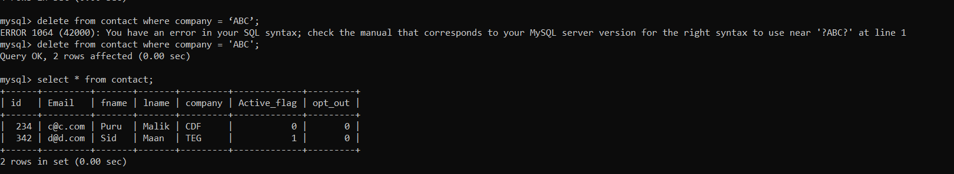

3.Insert a new row with id as 658, name as ‘mili’ , email as ‘mili@gmail.com’, company as ‘DGH’, active flag as 1, opt out flag as 1

Solution:

**Insert into contact(id,fname,Email,company,Active_flag,opt_out) value(658,"mili","mili@gmail.com","DGH",1,1);**

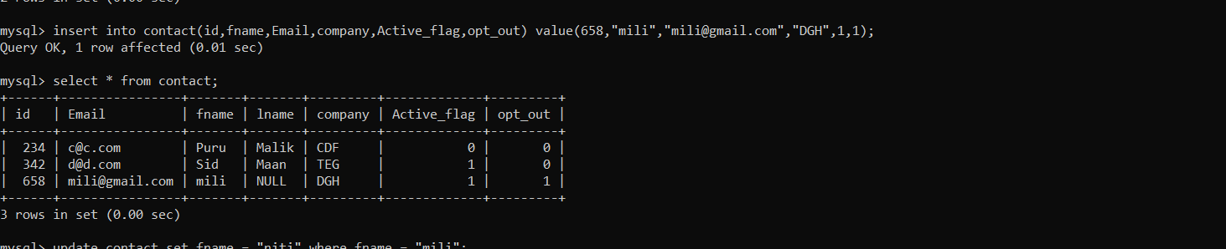

4.Pull out unique values of company column

Update name mili to niti

Solution:

**update contact set fname = "niti" where fname = "mili";**

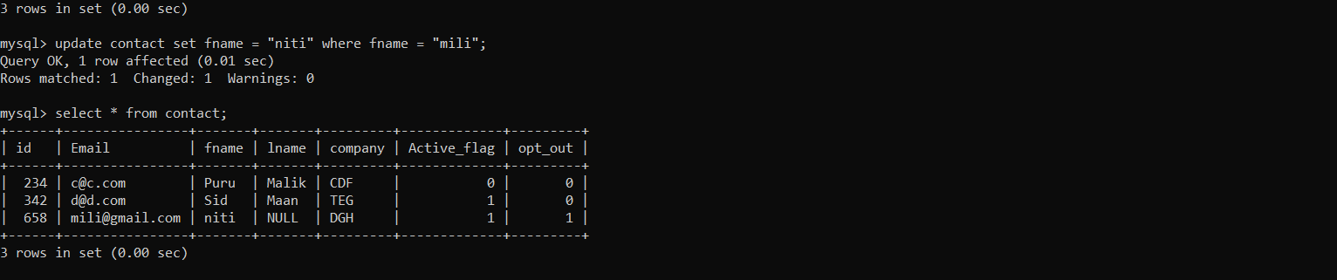

Some of The Most Important SQL Commands

* SELECT - extracts data from a database
* UPDATE - updates data in a database
* DELETE - deletes data from a database
* INSERT INTO - inserts new data into a database
* CREATE DATABASE - creates a new database
* ALTER DATABASE - modifies a database
* CREATE TABLE - creates a new table
* ALTER TABLE - modifies a table
* DROP TABLE - deletes a table
* CREATE INDEX - creates an index (search key)
* DROP INDEX - deletes an index